**Laboratory Two**



**Javier Jesús Macossay-Hernández**

**EE348L – Electronic Circuits**

**University of Southern California**

**Professor Susan Schober**

**Introduction**

In circuit design, specialized software is used as a tool to analyze and design circuits. These softwares are helpful when designing extensive circuits that will required significant amount of time to analyze. HSpice, which is distributed by Synopsis, is the circuit design software that will be used in class. The purpose of this laboratory is to help the students explore and get familiar with HSpice. In addition, circuits with operating amplifiers will be analyzed by hand and software simulations. Furthermore, hand and simulation results will be compared. The differences in results between the two different methods are being investigated in this laboratory.

Exercise 1

**Procedure**

On Exercise 1, HSpice simulations were done to learn how to do transient sweeps with changing parameters. The resulting plots were analyzed in WaveView Analyzer.

**Data**

The following images are screenshots from the HSpice output file.

Grouped graphs

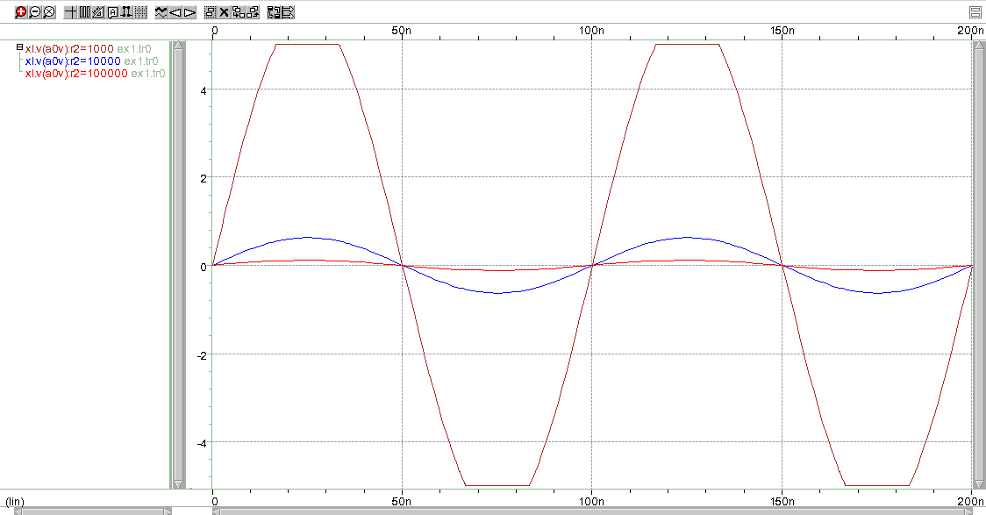

Ungrouped graphs

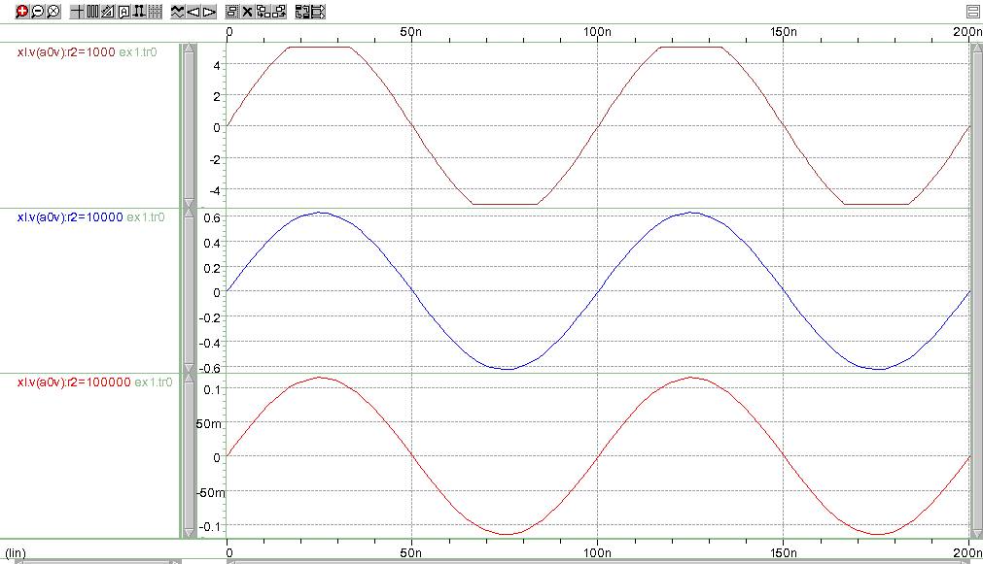

Netlist

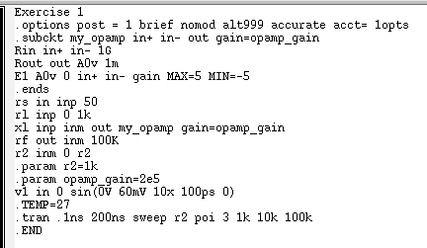

**Questions**

No questions were asked in this exercise.

**Discussion**

The results form the HSpice simulation match with the hand calculations. Therefore, the hand calculations were done correctly. As the value of R2 increases, 1k, 10k, and 100k, the gain decreases, 96.19, 10.48, and 1.905, respectively.

Exercise 2

**Procedure**

On Exercise 2, HSpice simulations were done to learn how to do alter statements with changing parameters. The resulting plots were analyzed in WaveView Analyzer.

**Data**

All gains

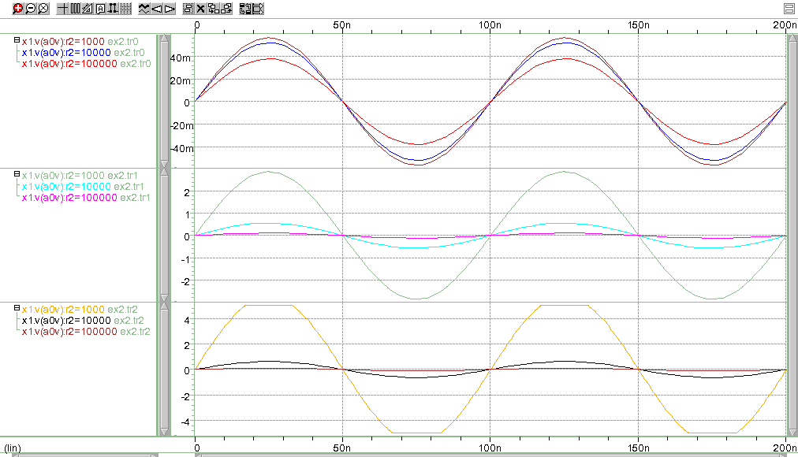

Grouped graphs, Gain = 1

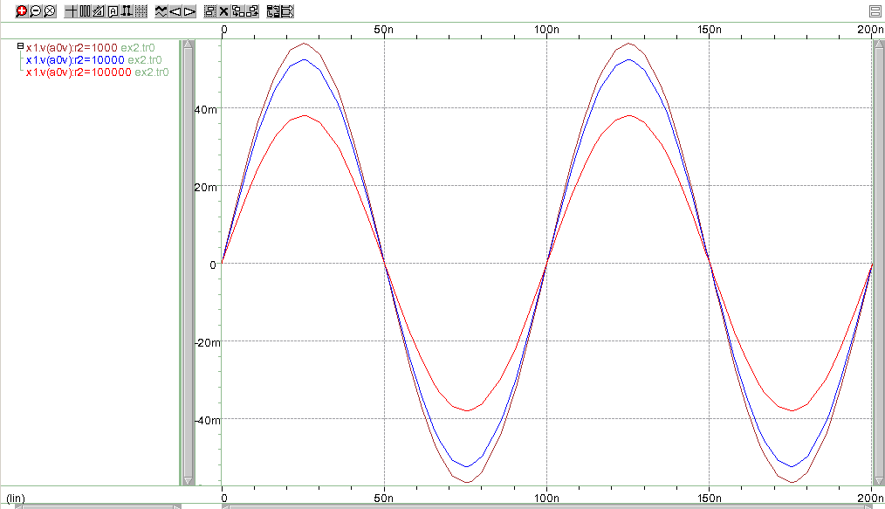

Ungrouped graphs, Gain = 1

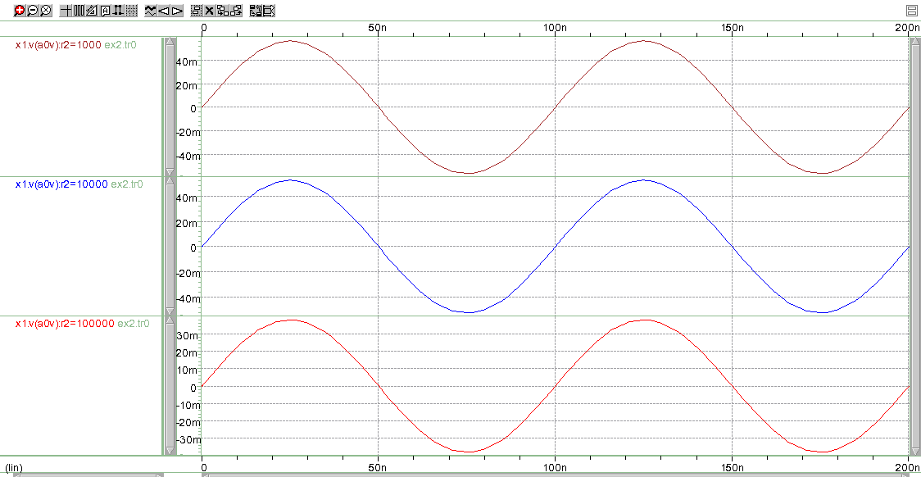

Grouped graphs, Gain = 100

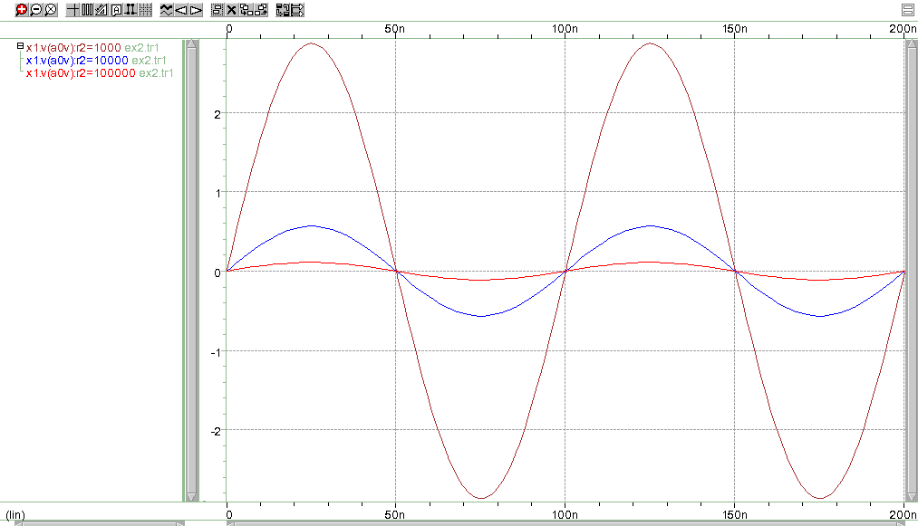

Ungrouped graphs, Gain = 100

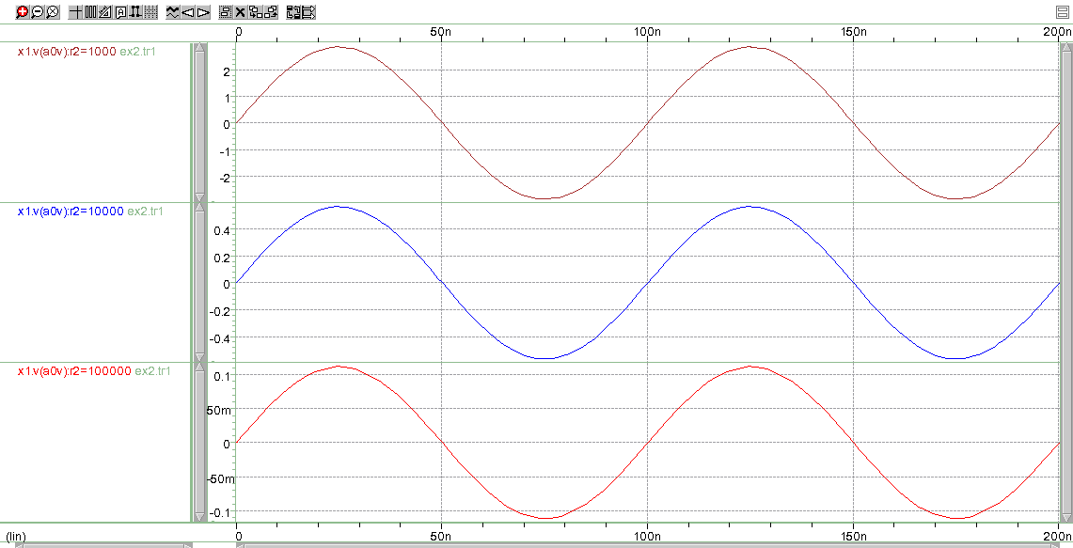

Grouped graphs, Gain = 10000

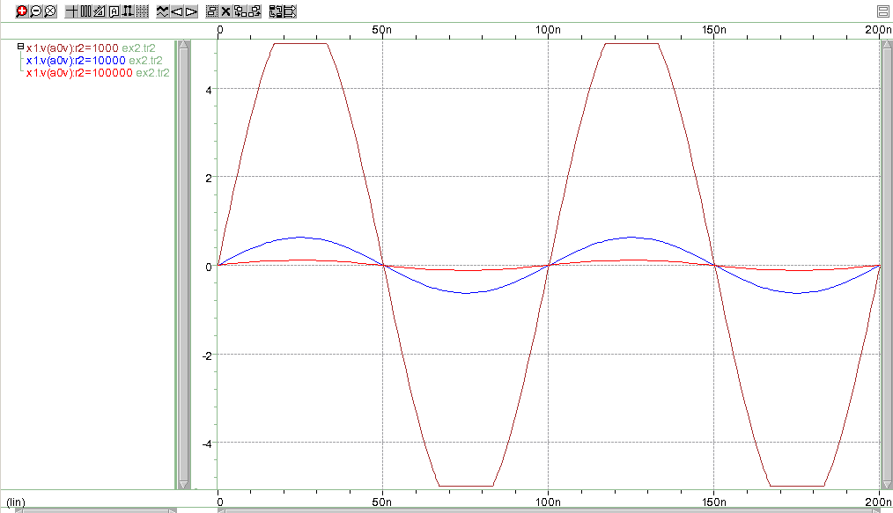

Ungrouped graphs, Gain = 10000

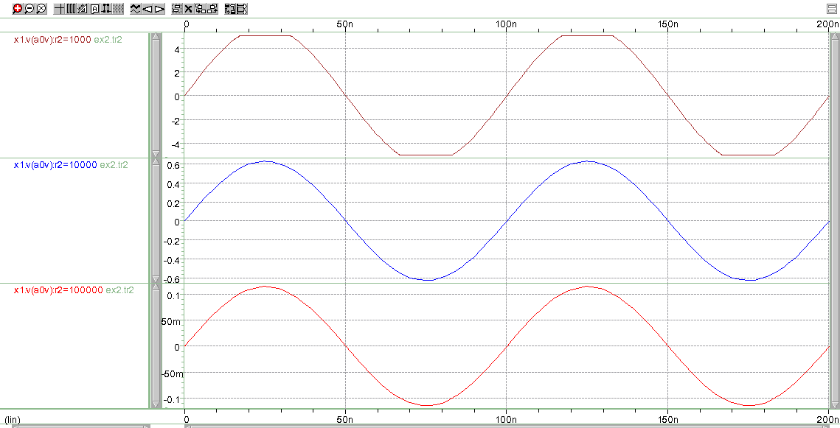

Netlist

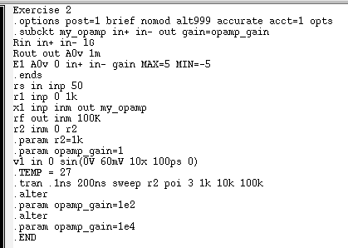

**Questions**

No questions were asked in this exercise.

**Discussion**

As the gain increased, the output of the 10k and 100k resistors decreased, which means that the output voltage decreases as the resistor value increases, but the gain is proportional to the output voltage. In addition, when we used a gain equal to 10,000 we reached the saturation poin when using the 1k resistor because we cannot exceed the maximum and minimum values of 5 V and -5 V, respectively.

Exercise 3

**Procedure.**

On Exercise 3, HSpice simulations were done to learn how to do alter statements, change parameters, and AC sweeps simultaneously. The resulting plots were analyzed in WaveView Analyzer.

**Data**

All graphs of gain in dB

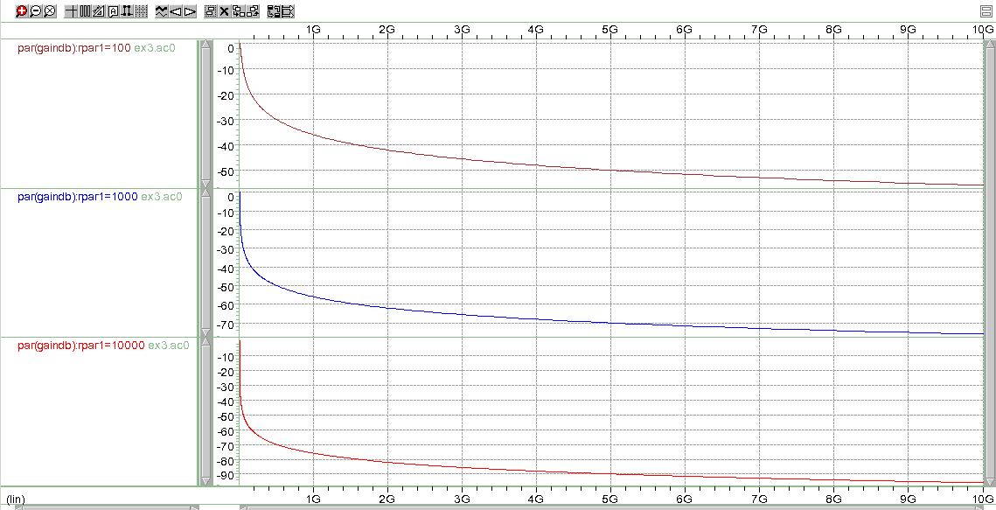

All graphs of phase

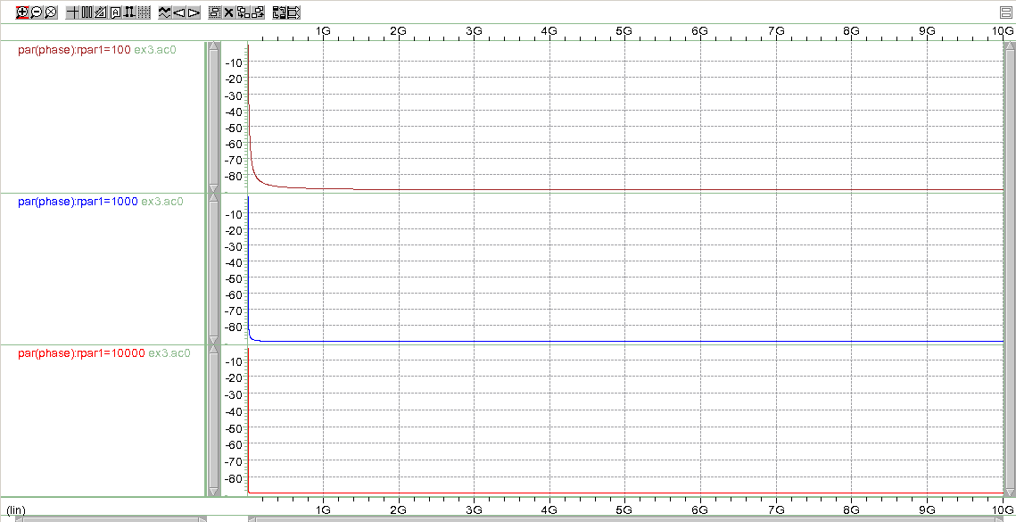

100 Ω Graph

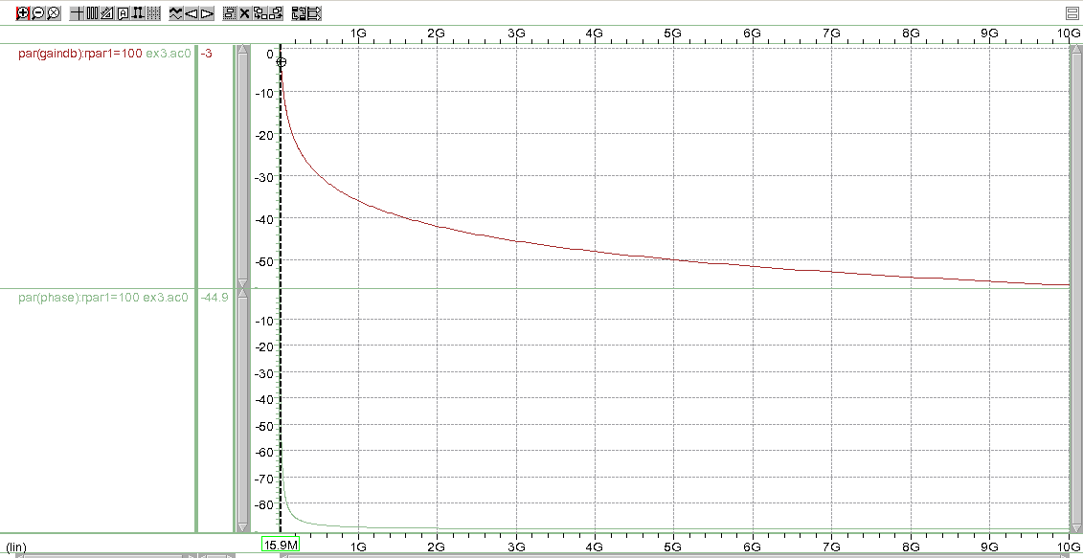

1000 Ω Graph

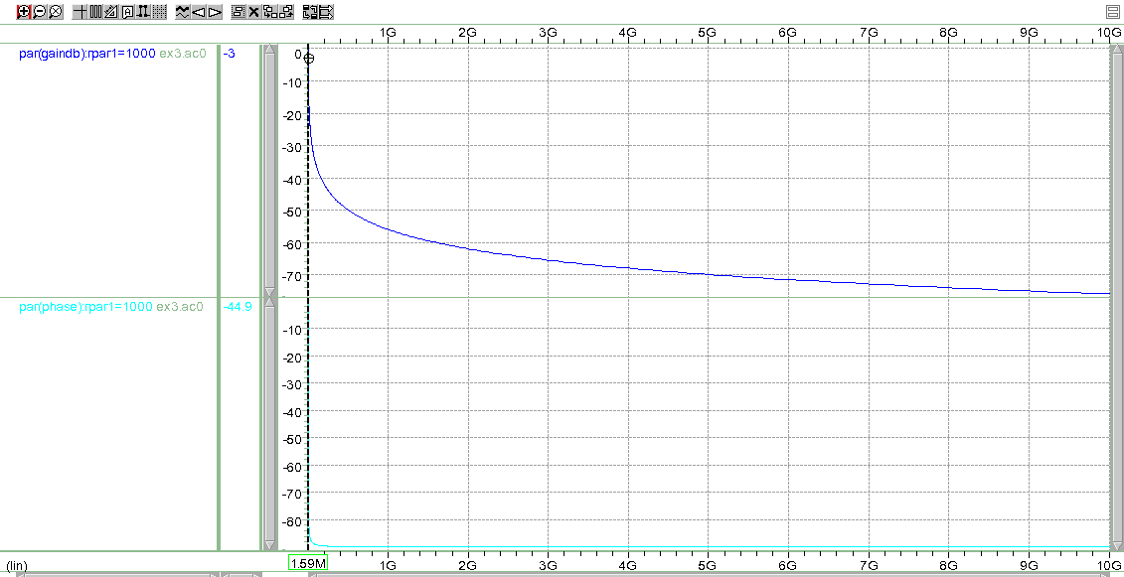

10000 Ω Graph

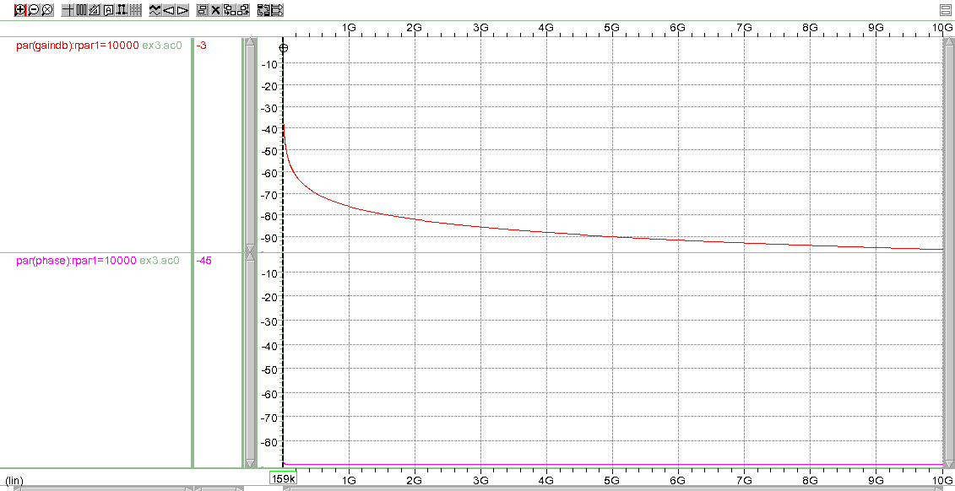

Netlist

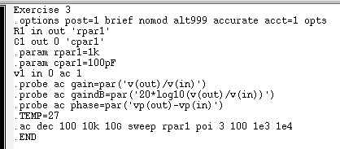

**Questions**

According to the hand calculations, the -3 dB frequency for the 100 Ω resistor should be 15. 9 MHz, 1.59 MHz for 1 kΩ, and 159 kHz for 10 kΩ. In addition, the simulations agree with the hand calculations by showing the same -3 dB frequency and -45° phase.

**Discussion**

The results from the HSpice simulation match with the hand calculations. Therefore, the hand calculations were done correctly. Furthermore, the objective of learning how to do alter statements, change parameters, and AC sweeps simultaneously was accomplished.

Exercise 4

**Procedure**

On Exercise 4, HSpice simulations were used to construct a low pass filter with RC components. In addition, hand calculations were performed to analyze the circuit and compare the results with the simulations. In the theoretical portion, transfer functions were derived.

**Data**

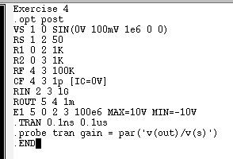

**Questions**

The low frequency gain in dB is 39.66 dB and the high frequency gain in dB is -0.4245 dB. The time constant associated with the pole caused by Cf is 1*10-7. Finally, the one associated with the zero is 9.9. If we want to plot 10 periods, we should use 10 μs, and 0.1 ns for 100 points per period.

**Discussion**

I was unable to do the simulations because the netlist did not work.

**Conclusion**

The results clearly agree with the objective of the lab that is to teach students how to use HSpice and WaveView Analyzer. I would like to make a suggestion about the laboratory. Exercises 4, 5, and 6 required highly technical knowledge and I was unable to finish it even after going to office hours. In addition, the manual is not clear enough and it is hard to put the pieces together to get the simulations for this lab and for Prelab #3.